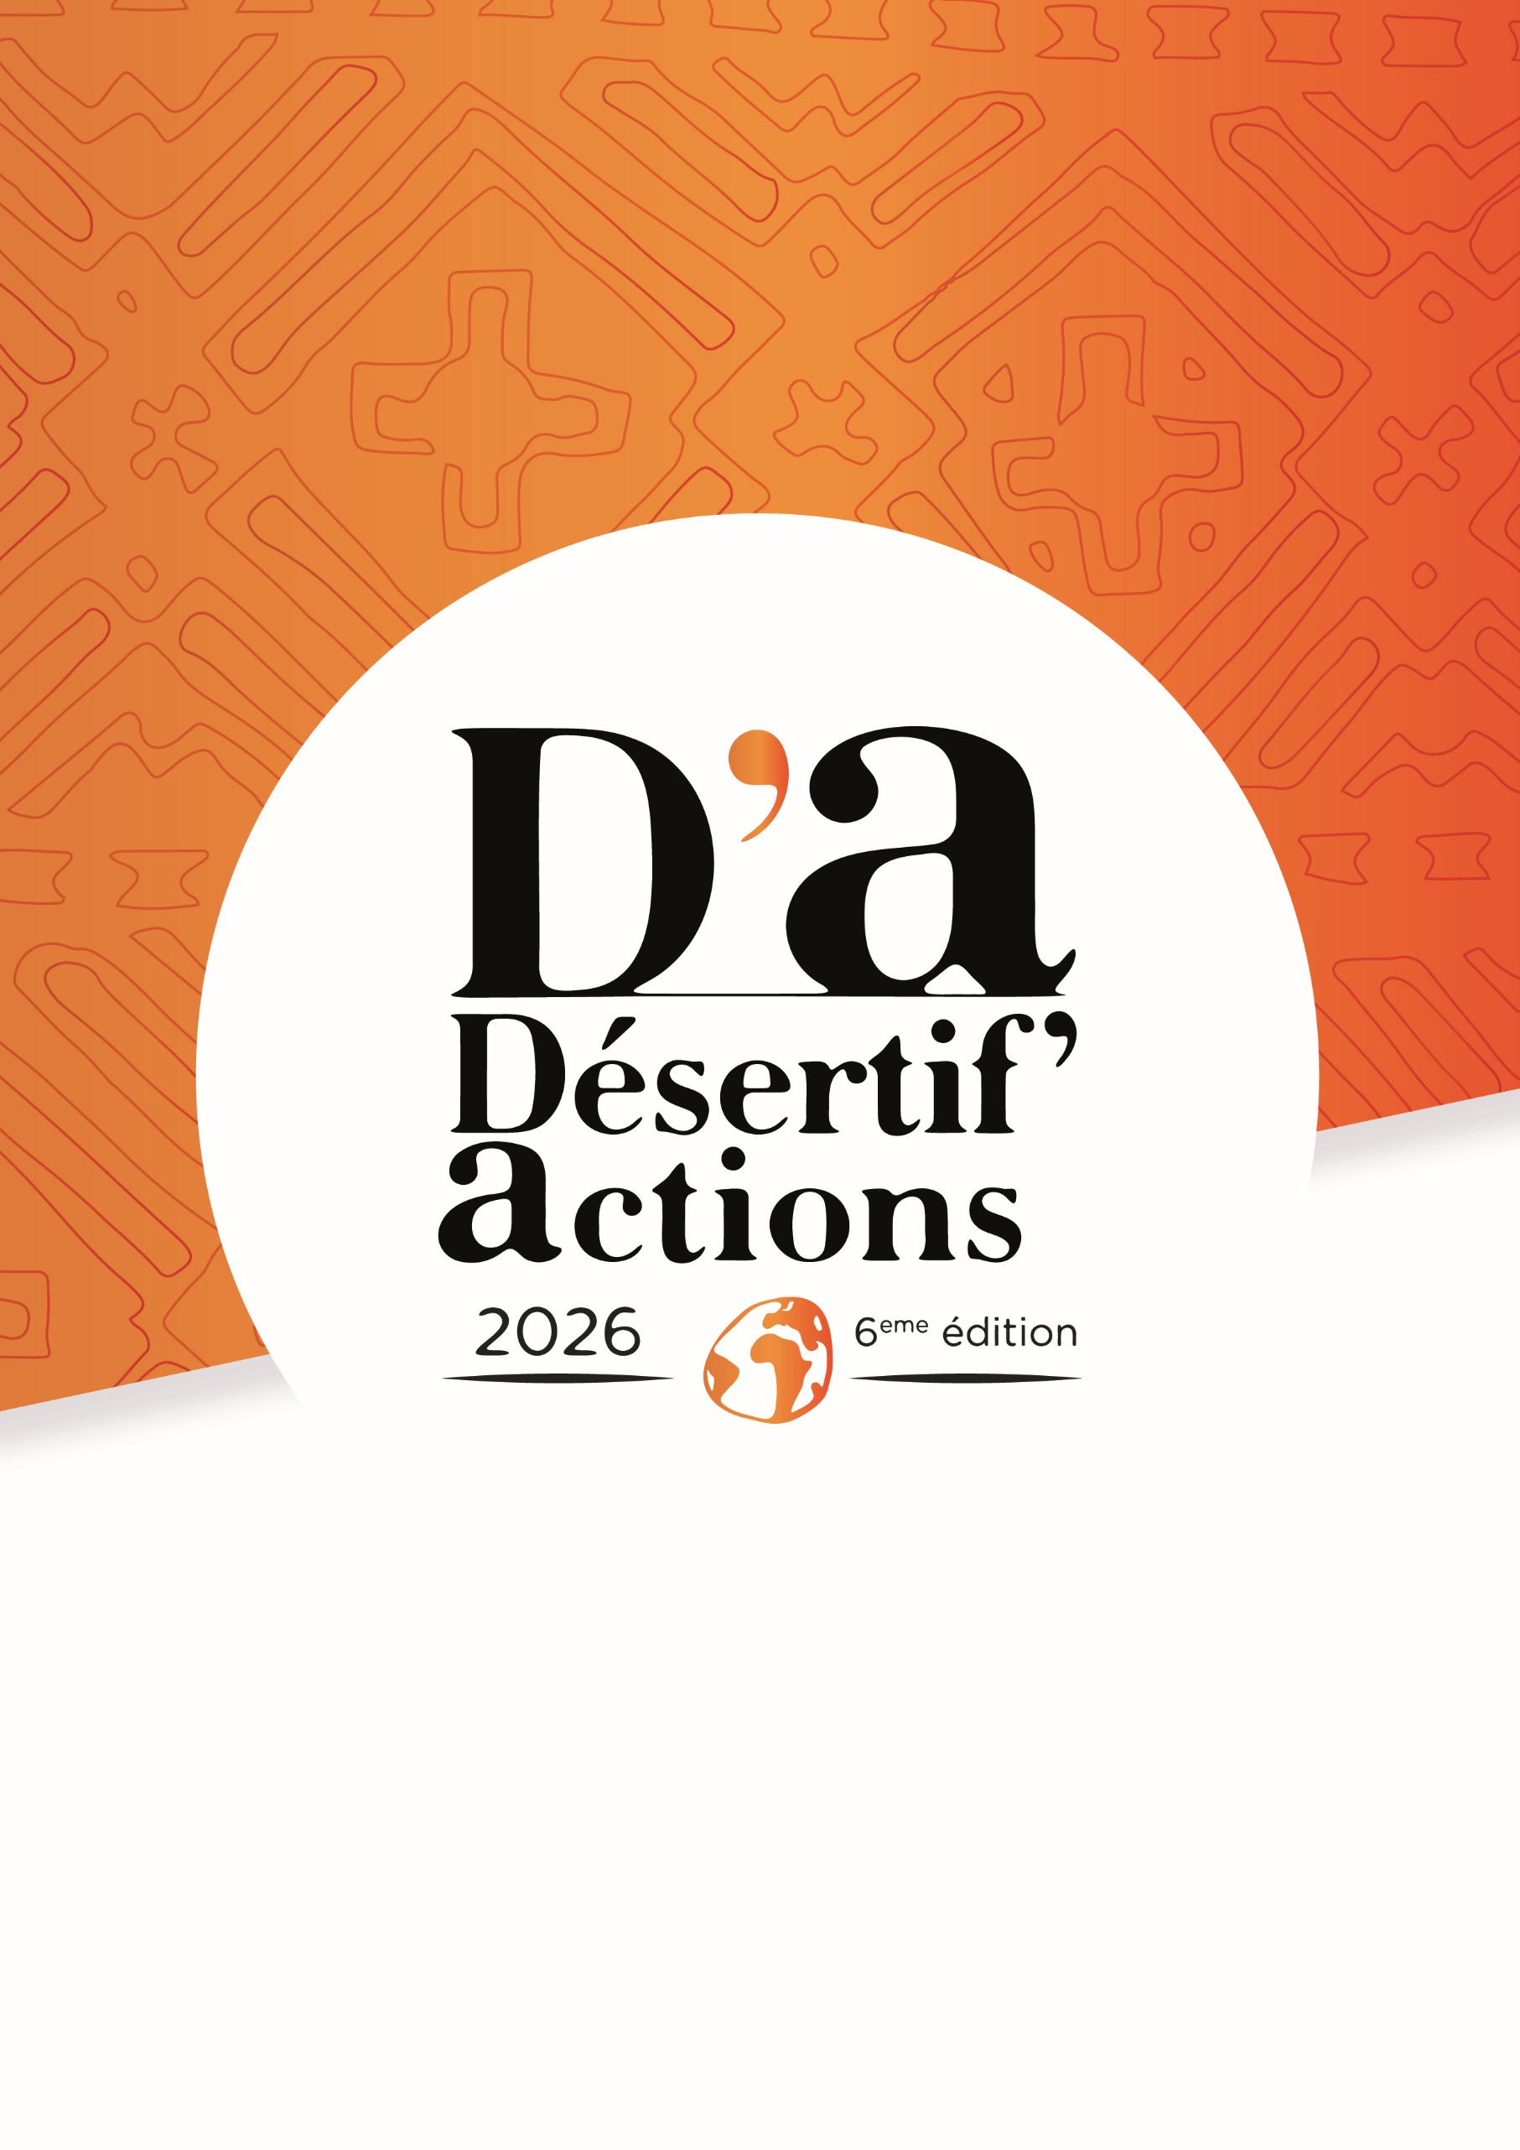
Title


Co-organised by



In partnership with




For drought-resilient territories:
let’s act from now on !





With the financial support of
In partnership with
Co-organised by

